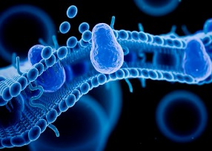
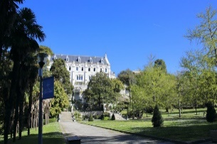
Program Winterschool - December 12-16, 2022
« Biomembranes, Pharmacology and Therapeutics »

Monday 12th: Biological membranes and cellular compartments

13:30-14:30 Bruno Antonny: Lipid membrane territories in the cell
14:30-15:30 Joost Holthuis: Evolutionary origin of biomembranes
15:30-16:30 Hélène Barelli: Phospholipid polyunsaturated effects on biophysical properties of PM
16:30-17:30 Delphine Bichet: Ion channels in all cellular compartments

Tuesday 13th: Bio-membranes and cell signaling

08:30-09:30 Guillaume Drin: Lipid synthesis and cell signaling
09:30-10:30 Guillaume Lenoir: Regulatory mechanism of eukaryotic lipid flippases
10:30-11:30 Thorsten Hornemann: Rare disease of sphingolipid metabolism
11:30-12:30 Nazzareno D’avanzo: Lipid regulation of ion channels

Innovative tools to study membrane lipids

14:00-15:00 Romain Gautier: Bioinformatic approaches for studying biomembranes
15:00-16:00 Takeshi Harayama: Gene disruption strategy to analyze and manipulate lipid co-regulatory networks
16:00-17:00 Florian Fröhlich: Mass spectrometry of membrane lipids

Wednesday 14th: Electrical properties of cell membranes

08:30-09:30 Olivier Soriani: Membrane proteins at the origin of bioelectricity
09:30-10:30 Massimo Mantegazza: Sodium channels in neurological disorders
10:30-11:30 Eric Boué-grabot: Synaptic and glial function of ATP P2X receptors in the brain
11:30-12:30 Laurent Counillon: Lithium isotopic fractionation by transporters and channels

Biophysical and imaging tools to study membrane proteins in cells

14:00-15:00 Sylvain Feliciangeli: Using fluorescence microscopy to study proteins
15:00-16:00 Paula Pousinha: Neuro-electrophysiological recording techniques
16:00-17:00 Sebastian Fernandez: In vivo-fiber photometry and optogenetic

Thursday 15th: Innovative tools to study purified membrane proteins

08:30-09:30 Isabelle Mus-Veteau: Heterologous expression of membrane proteins
09:30-10:30 Isabelle Broutin: Structural analysis of bacterial membrane proteins
10:30-11:30 Catherine Vénien-Bryan: Structural analysis of human membrane proteins
11:30-12:30 Jérémie Topin & Sébastien Fiorucci: Structure-based and ligand-based virtual screening of membrane proteins

Transfer of knowledge on bio-membranes to industry

14:00-15:00 Thierry Ferreira: Research valorisation
15:00-15:30 Isabelle Mus-Veteau: From lab to start-up
15:30-16:00 Jacques Bodennec, Gaoma Therapeutics : innovative lipids derivatives as drug candidates
16:00-16:30 Reza Sharif-Naemi, PteroTech Inc. : innovative product blocking the pain caused by lionfish and jellyfish stings
16:30-17:00 Sandy Blin: Insights into the work of a venture capital analyst in life sciences

Friday 16th: Targeting cell membrane components in therapy

08:30-09:30 Eric Lingueglia: Analgesic effects of mambalgin peptide inhibitors of acid-sensing ion channels
09:30-10:30 Anna Fassio: Membrane trafficking at the presynaptic terminal: physiological regulation and brain pathology
10:30-11:30 Frederic Becq: CFTR pharmacological modulators
11:30-12:30 Gérard Lambeau: Anti-PLA2R1 antibodies in diagnostic and prognostic of nephrotic syndrome

